[decltype](https://www.bilibili.com/video/av24180269/?p=13)

1. Decltype

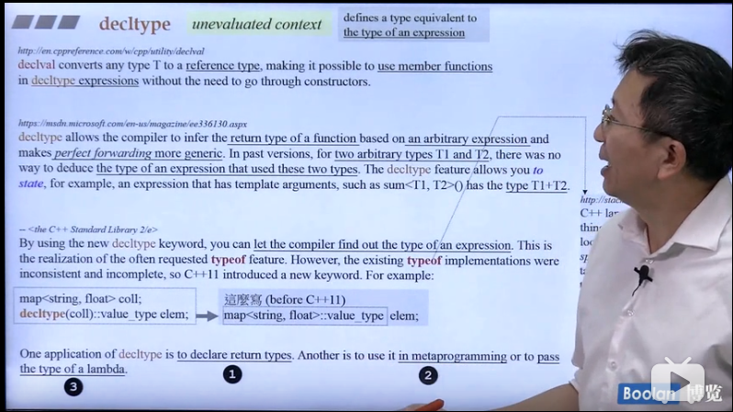

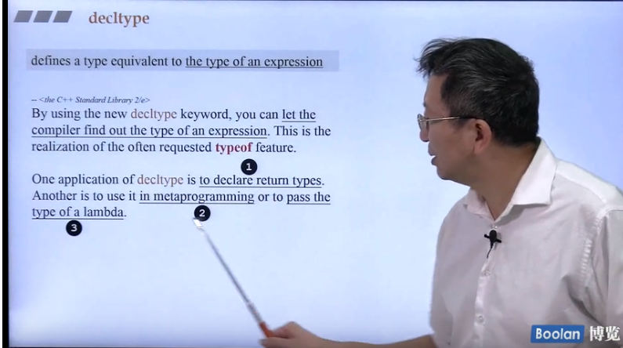

1. decltype三种应用

2.1 decltype:used to declare return type

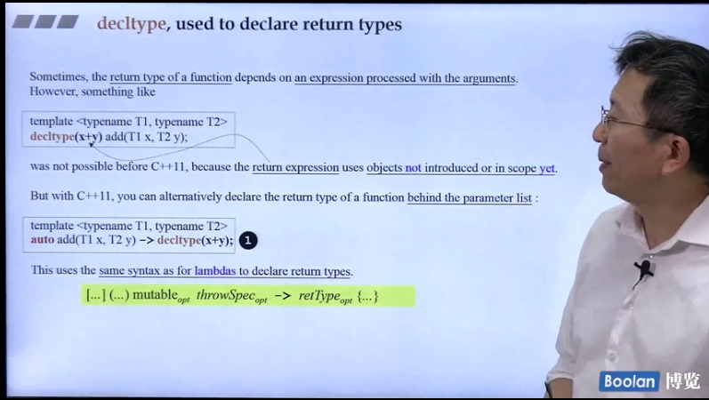

2.2 decltype:metaprogramming元编程

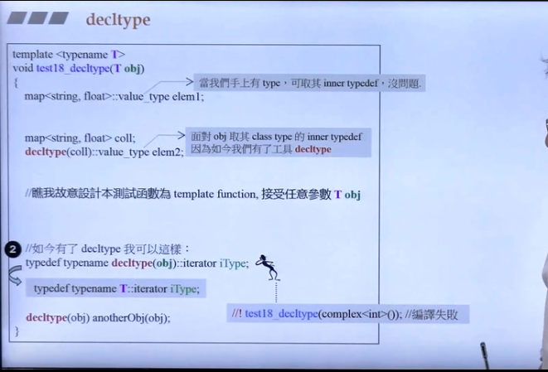

2.3 decltype:lambda 表达式

